PF LAB:8

24K-O514

MUHAMMAD

UMER FAROOQ

# QUESTION 1:

Write a C program to generate the following pattern:

1

1 2

1 2 3

1 2 3 4

OUTPUT:

## QUESTION 2:

Write a program to take a 2D array input from the user and display its transpose.

OUTPUT:

### QUESTION 3:

Create a 3D array representing 2 pages of a 3x3 matrix. Initialize it and find the sum of all the elements on each page.

OUTPUT:

#### QUESTION 4:

Write a C program that generates a sequence of prime numbers within a given range using nested loops.

OUTPUT:

##### QUESTION 5:

Generate a pattern of odd numbers in decreasing order starting from a user-specified number using nested loops.

##### 

OUTPUT:

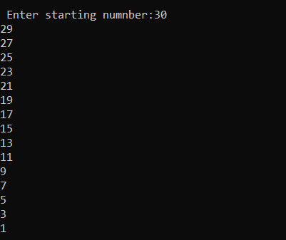

###### QUESTION 6:

Write a C program to find the saddle point(s) in a given 3x3 matrix. A saddle point is an element that is the smallest in its row and the largest in its column.

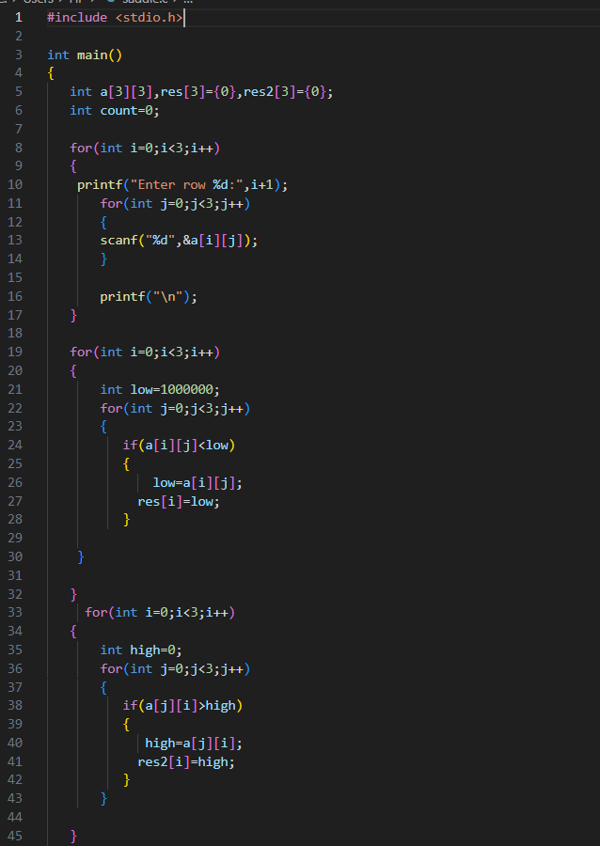

OUTPUT:

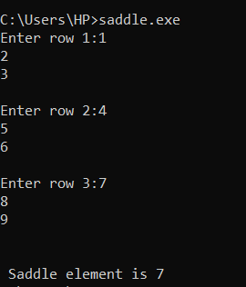

QUESTION 7:

Write a C program to multiply two matrices of size 3x3 and display the result matrix.

OUTPUT:

QUESTION 8:

Write a C program to generate a diamond shape pattern using nested loops. The program should take the number of rows for the upper half of the diamond as input from the user.

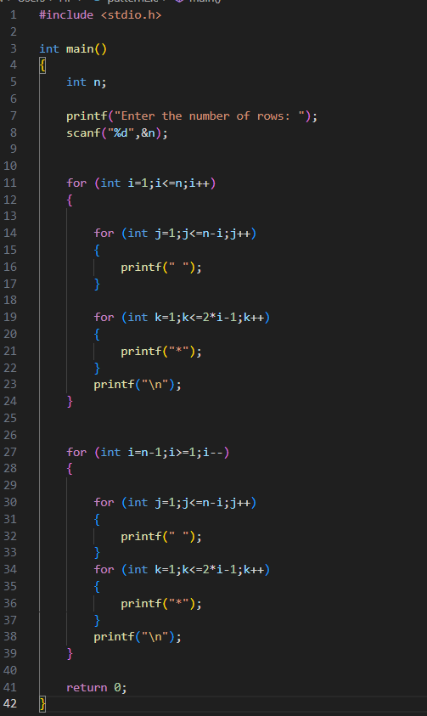

OUTPUT:

